Ideation Phase
Empathize & Discover
Date | 03 October 2026
Team ID | SWTID-2026-7282
Project Name | Implement Client Script & UI Policy (Incident)
Maximum Marks | 4 Marks
Empathy Map Canvas:
An empathy map is a simple, easy-to-digest visual that captures knowledge about a user’s behaviours and attitudes.
It is a useful tool to help teams better understand their users. Creating an effective solution requires understanding the true problem and the person who is experiencing it. The exercise of creating the map helps participants consider things from the user’s perspective along with his or her goals and challenges.
Example:
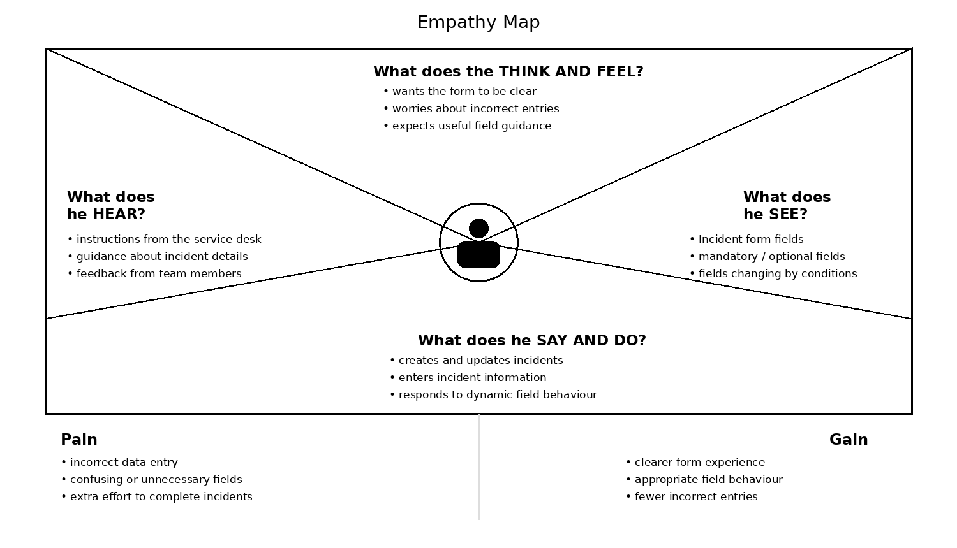
Reference: https://www.mural.co/templates/empathy-map-canvas

Example: ServiceNow Incident Management
